**THE WEALTH OF NATIONS – ASSIGNMENT**

**LOU GONZALES**

Date of submission: 27th August 2024

Table of Contents

Data – Policies and Procedures…………………………………………………………………………………. 3

Introduction………………………………………………………………………………………………………………. 2

Importance of adhering to policies…………………………………………………………….2

Excel – GDP worksheet tasks………………………………………………………………………3

1. Setting a password on the workbook ...............................................................3

2. Highlight column C and change the data to display in British Pound symbol.......4

3. Turn the GDP sheet into a table.......................................................................6

4. Filter the table to display only the information for 2019................................... 11

5. Creating a chart for Rank, Country, and GDP per Capita ................................. 12

6. Editing the chart .......................................................................................... 13

7. Move the chart to a new sheet tab and label with a suitable name ................... 15

8. Creating a sort for the top 20 highest ranking countries................................... 16

9. Creating a bar chart of the sorted data .......................................................... 17

10. Adding colour to the background............................................................... 18

11. Macro buttons ......................................................................................... 18

12. Copying the sheet into a Word document................................................... 19

13. Adding a header and footer to the worksheet.............................................. 20

Reflection.............................................................................................................. 20

Data – Policies and Procedures

Introduction

When working with data the following policies need to be adhered to:

* The Data Protection Act 2018 is a United Kingdom Act of Parliament which updates data protection laws in the UK. It is a national law which complements the European Union’s General Data Protection Regulation (GDPR).
* The GDPR is a wide-ranging regulation designed to protect the privacy of individuals in the European Union (EU) and give them control over how their personal data is processed, including how it’s collected, stored and used. It affects every company in the world that processes personal data about people in the EU.

In this particular scenario when working with the ‘The Wealth of nations’ data we have to ensure to take practical steps to comply with the legal obligation and the following principles because we are working with some data form the EU:

* used fairly, lawfully and transparently
* used for specified, explicit purposes
* used in a way that is adequate, relevant and limited to only what is necessary
* accurate and, where necessary, kept up to date
* kept for no longer than is necessary
* handled in a way that ensures appropriate security, including protection against unlawful or unauthorised processing, access, loss, destruction or damage
* accountability

What we have policies for and their level of detail varies, but effective data protection policies and procedures can help us to take the practical steps to comply with the legal obligations. A data governance policy is a set of rules, procedures and guidelines that define how we as data analysts collect, store, use and handle data. With these policies in place, data can be used effectively, efficiently, ethically and in compliance with regulatory guidelines.

In conclusion, data protection is a critical aspect of the role of a data analyst and must be taken seriously to ensure that sensitive information is kept secure.

Excel – GDP worksheet tasks

In this section of the report, the method in which tasks were completed can be found with

supporting screenshots. A brief explanation is also provided.

1. Setting a password on the workbook

Setting a password on the workbook is crucial for several reasons. It protects sensitive information - passwords help safeguard personal and business-related data from unauthorised access. This is especially important if the workbook contains confidential information like personal details or financial records.

It prevents unauthorised access – by setting a password we can control who can modify the workbook. This ensures the integrity and accuracy of the data, preventing accidental or malicious changes.

It complies with regulations – for businesses, password protection can help meet legal and regulatory requirements for data security, such as GDPR.

Screenshots are displayed below to show how I completed the task of setting a password on the workbook.

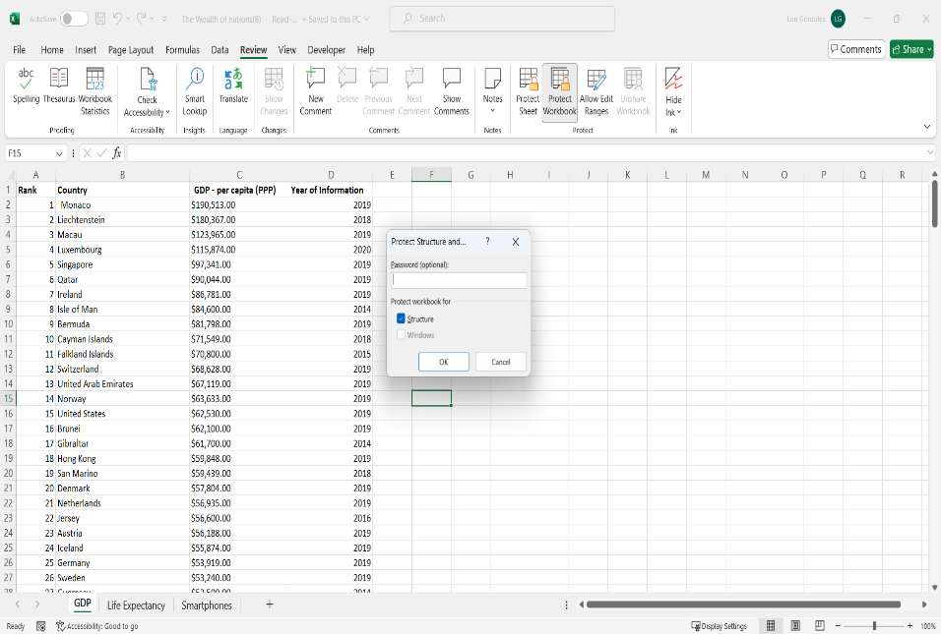

To set a password to protect the workbook, I selected Review tab of the ribbon and under the protect group selected ‘protect workbook’ as shown above. A new window will pop up and a new password can be typed in. It is essential to create a strong password that consist of a combination of letters, numbers and symbols.

1. Highlight column C and change the data to display in British Pound symbol

Since we live in the UK, we should change the symbol that represents data by the pound sterling (£).

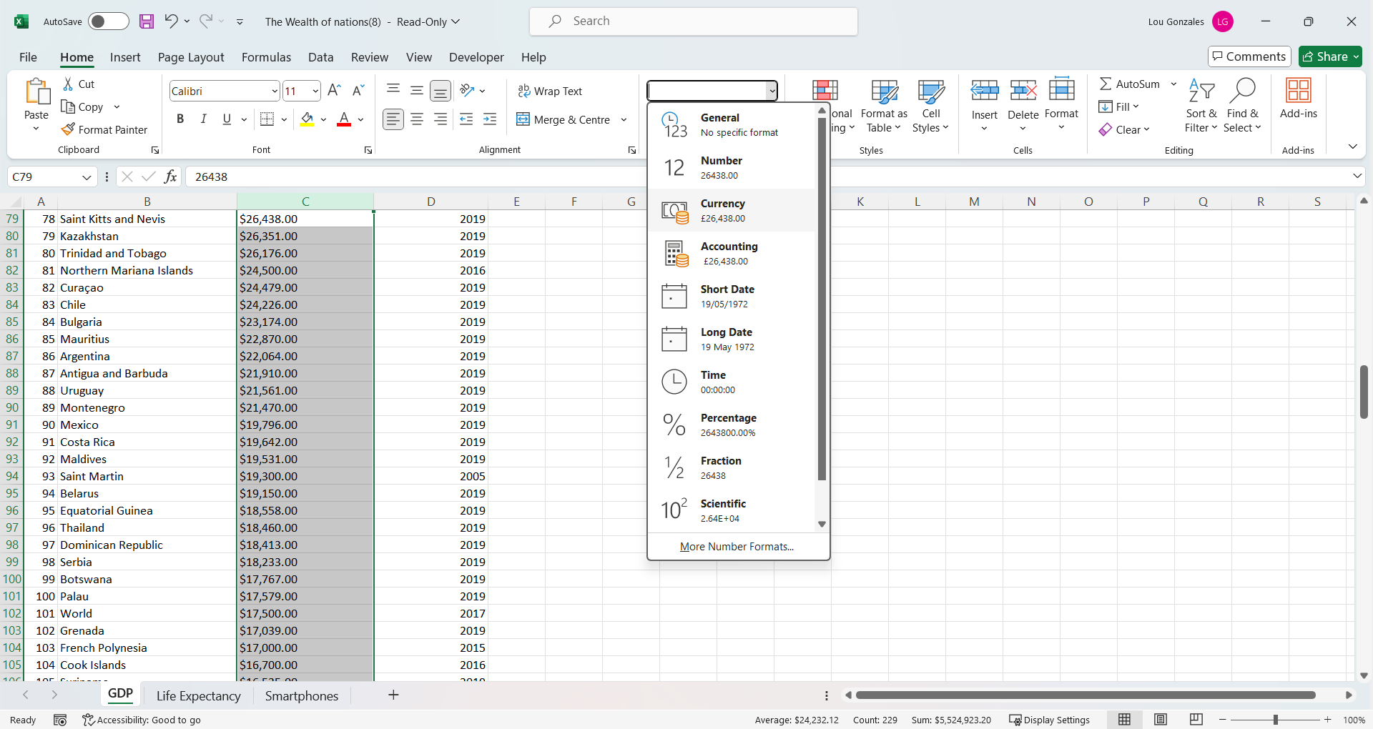

Before converting the GDP per capita (PPP) column into British Pounds, the column needs to be highlighted first. This is done by clicking the ‘C’ letter above the column header. The data types are found in the Home tab in the category list, when scrolling down I selected ‘accounting’. The entire column is then represented in British pounds.

1. Turn the GDP sheet into a table

By turning data into a table, it creates improved visualisation of the data as well as greater understanding.

In order to format the GDP sheet into a table, the whole data(not the entire worksheet) needs to be highlighted, then within the Home tab in the styles group click on ‘Format as Table’ option and choose a table style. When choosing a table style we should consider selecting the colours for individuals with visual impairments. It this case the colour red and green together should be avoided.

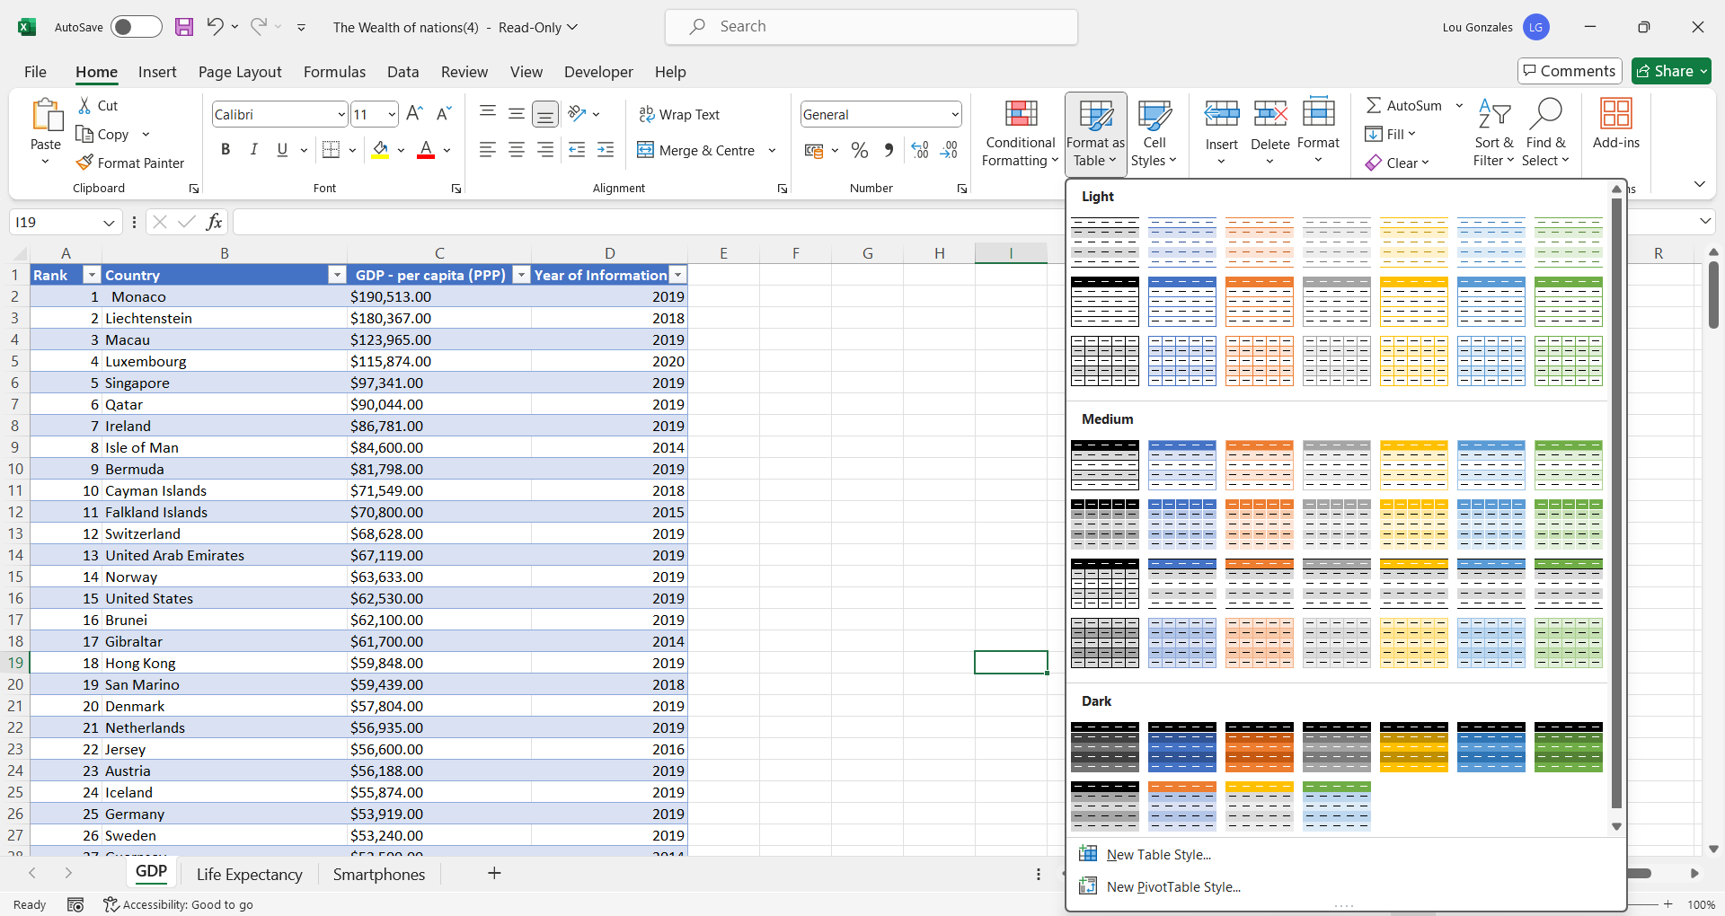

1. Filter the table to display only the information for 2019

The most important part prior to presenting the data is cleaning the data to capture the essential part for visualisation. Filtering the information for 2019 only is easily done by clicking on the filter below the column D in D1 cell which will bring up a new window with the following options. All the years are deselected and select 2019 only.

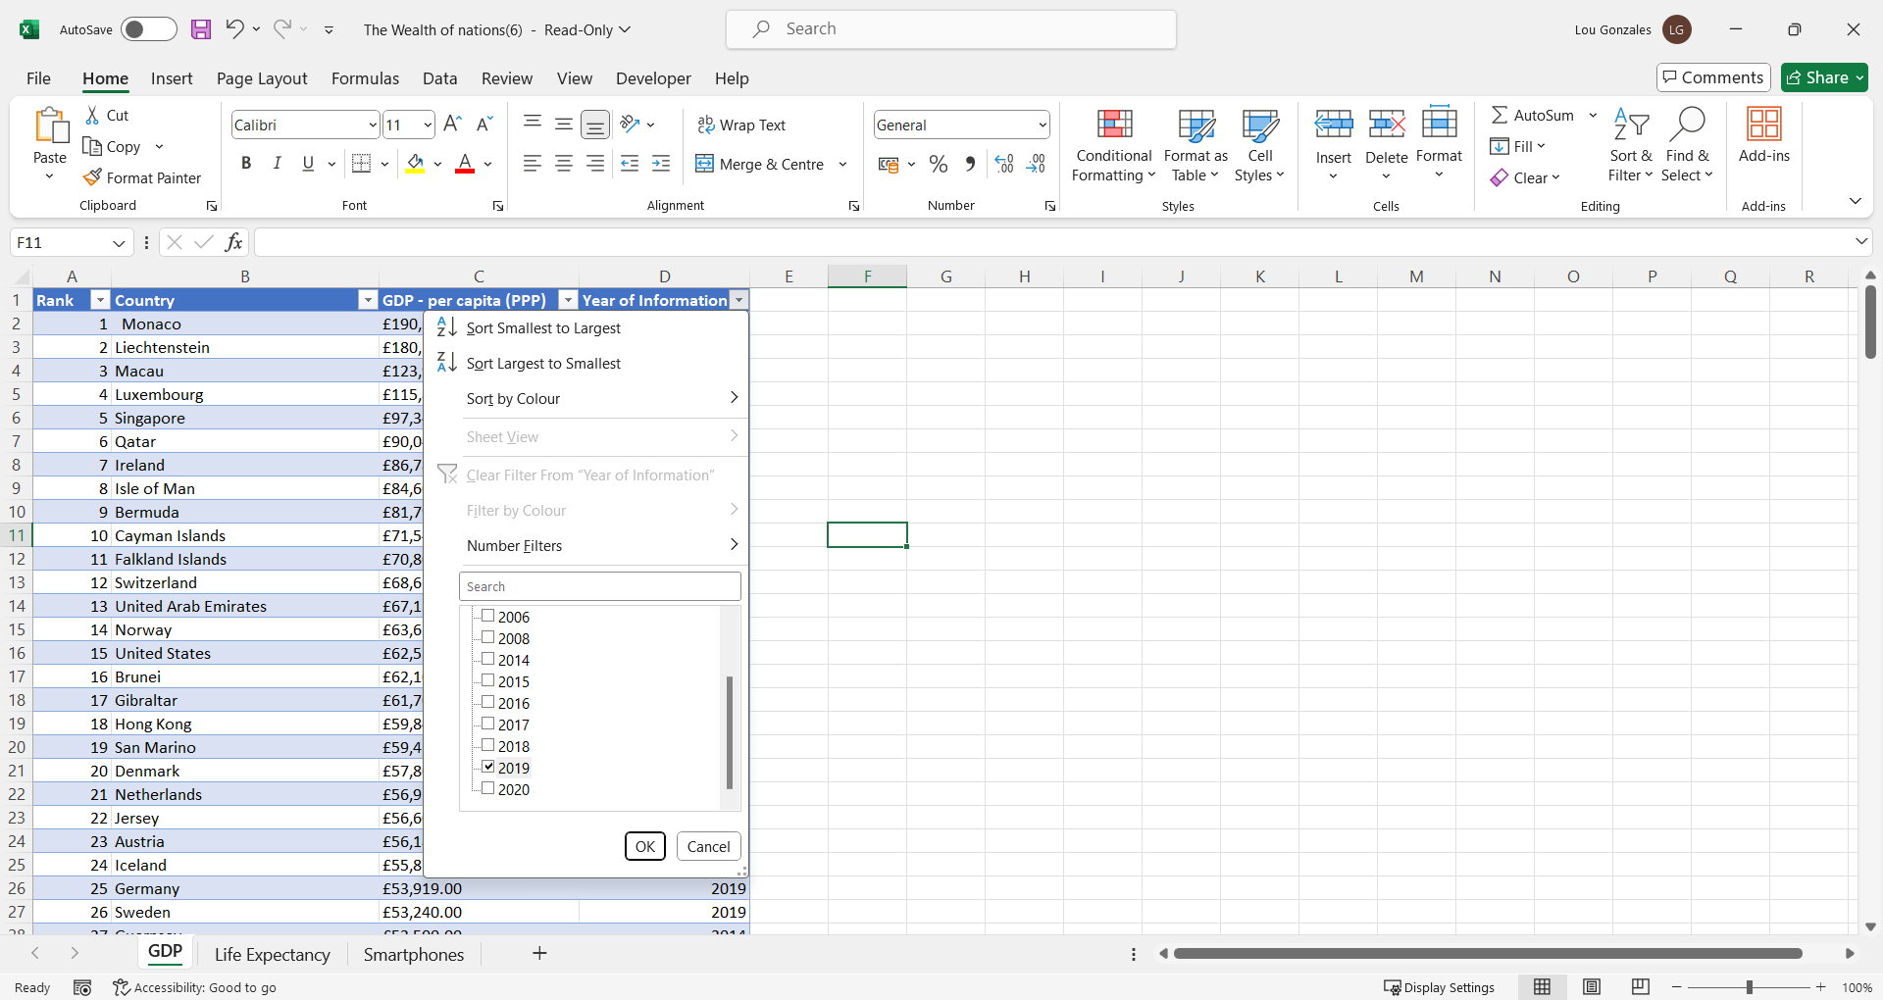

1. Creating a chart for Rank, Country, and GDP per Capita

There are a few steps involved in creating a chart that displays the following data ‘Rank, Country and GDP’. Before selecting a type of chart, the following columns need to be highlighted (Rank, Country and GDP per Capita). The next step is to navigate to the ‘Insert’ tab of the ribbon and click on the ‘Insert column and bar chart‘ button, under Charts group. We’ll find all types of charts that we can choose from. In this instance the most appropriate visual chart is a bar chart as the data is pretty long.

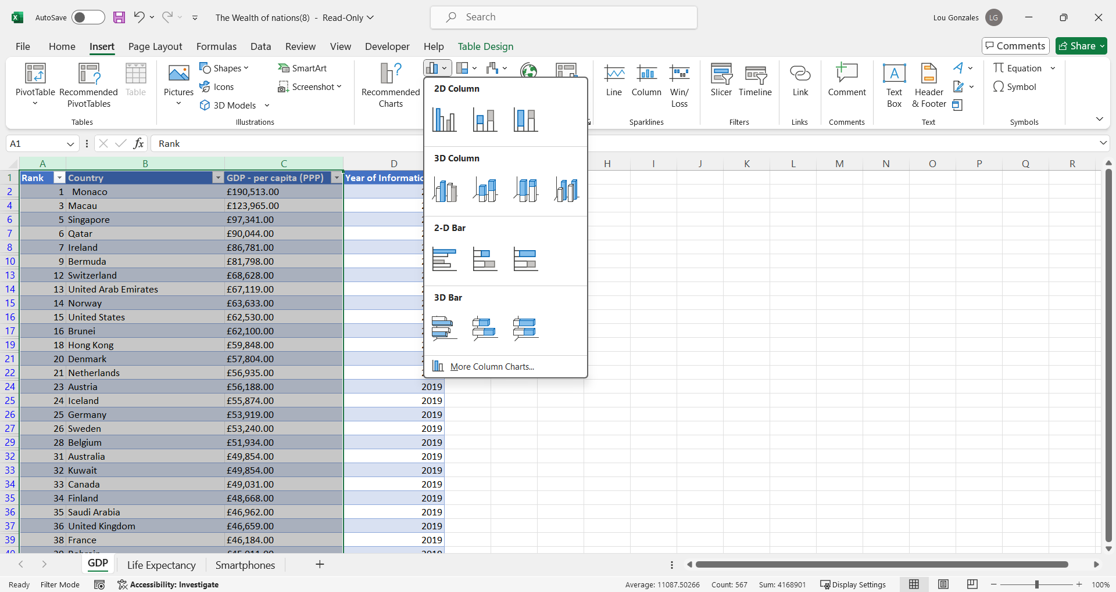

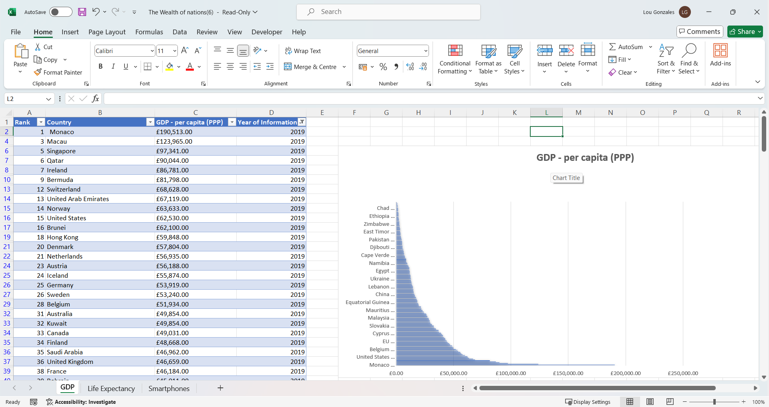

1. Editing the chart

After the chart had generated by Excel, I did some needed editing to the chart like, adding a title, X and Y axis and legend. One of the way to edit a chart is to go to the ‘chart elements’ found on the right hand side of a chart. Firstly, a chart needs to be highlighted, then the three buttons/tools will appear. Selecting the top button, will show the list of different elements of charts.

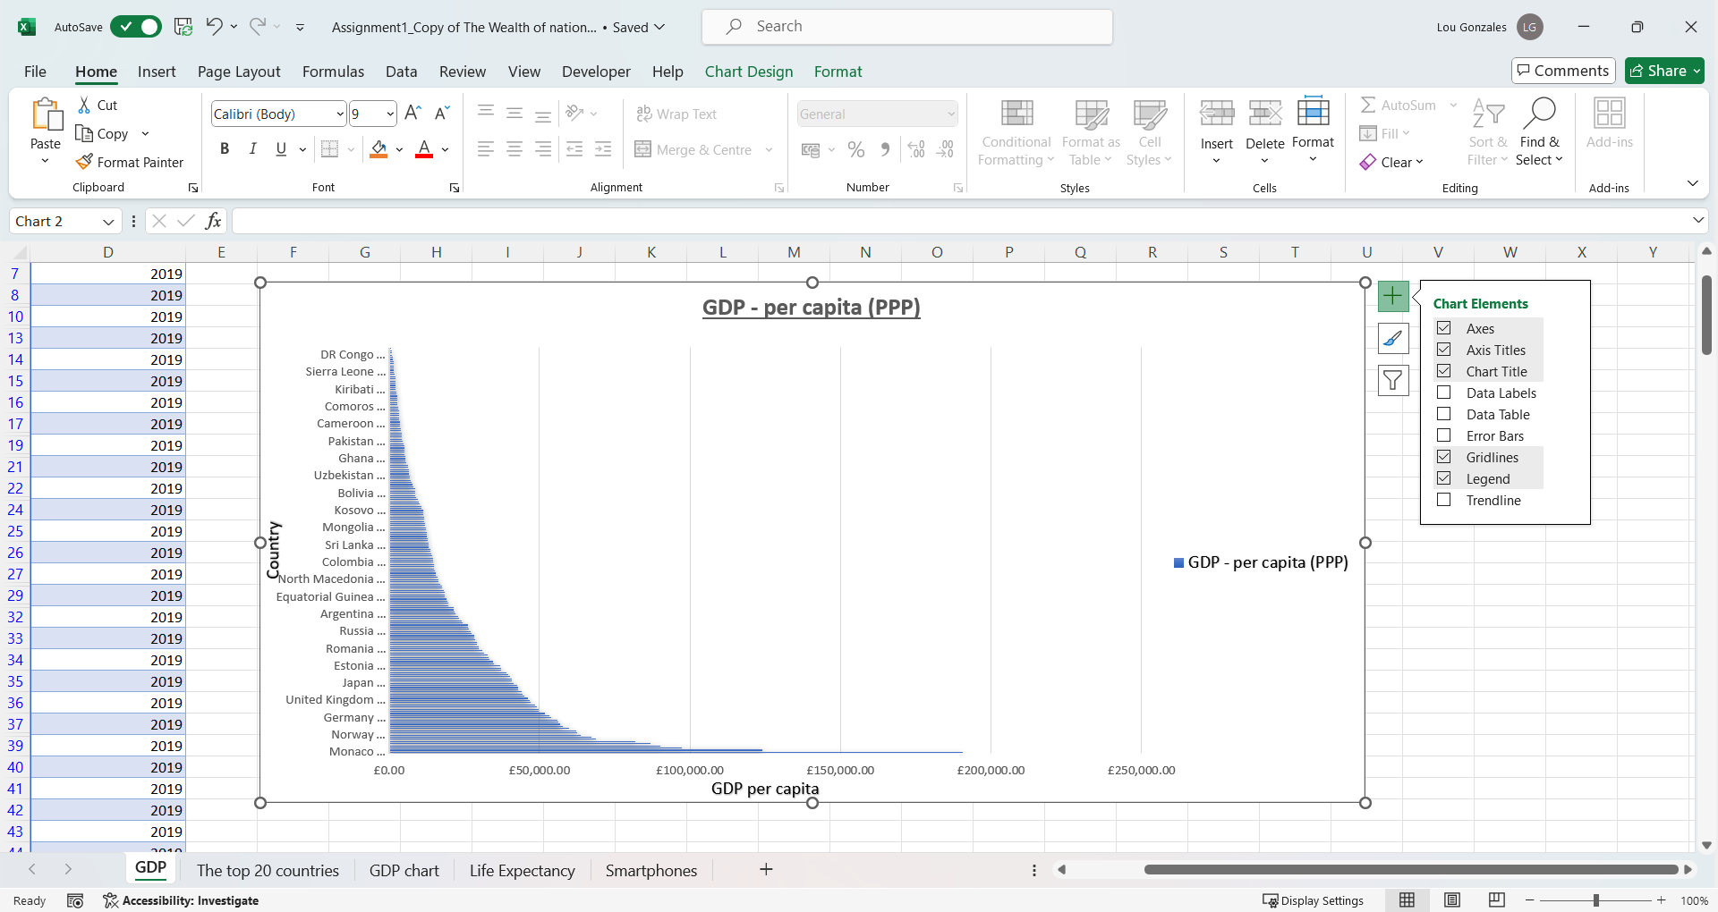

In addition to that we can also chose a style from the ‘Chart Design’ tab in the ribbon on the top. From here, I was able to choose the appropriate style, visually appealing to customers.

1. Move the chart to a new sheet tab and label with a suitable name

The chart was moved to a new sheet tab which was labelled GDP chart. This was done by selecting the ‘+’ button at the bottom of Excel where all the existing worksheets are located. The title of the chart is GDP – per capita (PPP). The new sheet was renamed by right clicking on the worksheet (Sheet1) and selecting the rename option. The copying the chart can be done by first selecting the chart, then with the Ctrl + C command navigate to the new worksheet and press Ctrl + V to paste the chart into the new worksheet as seen below.

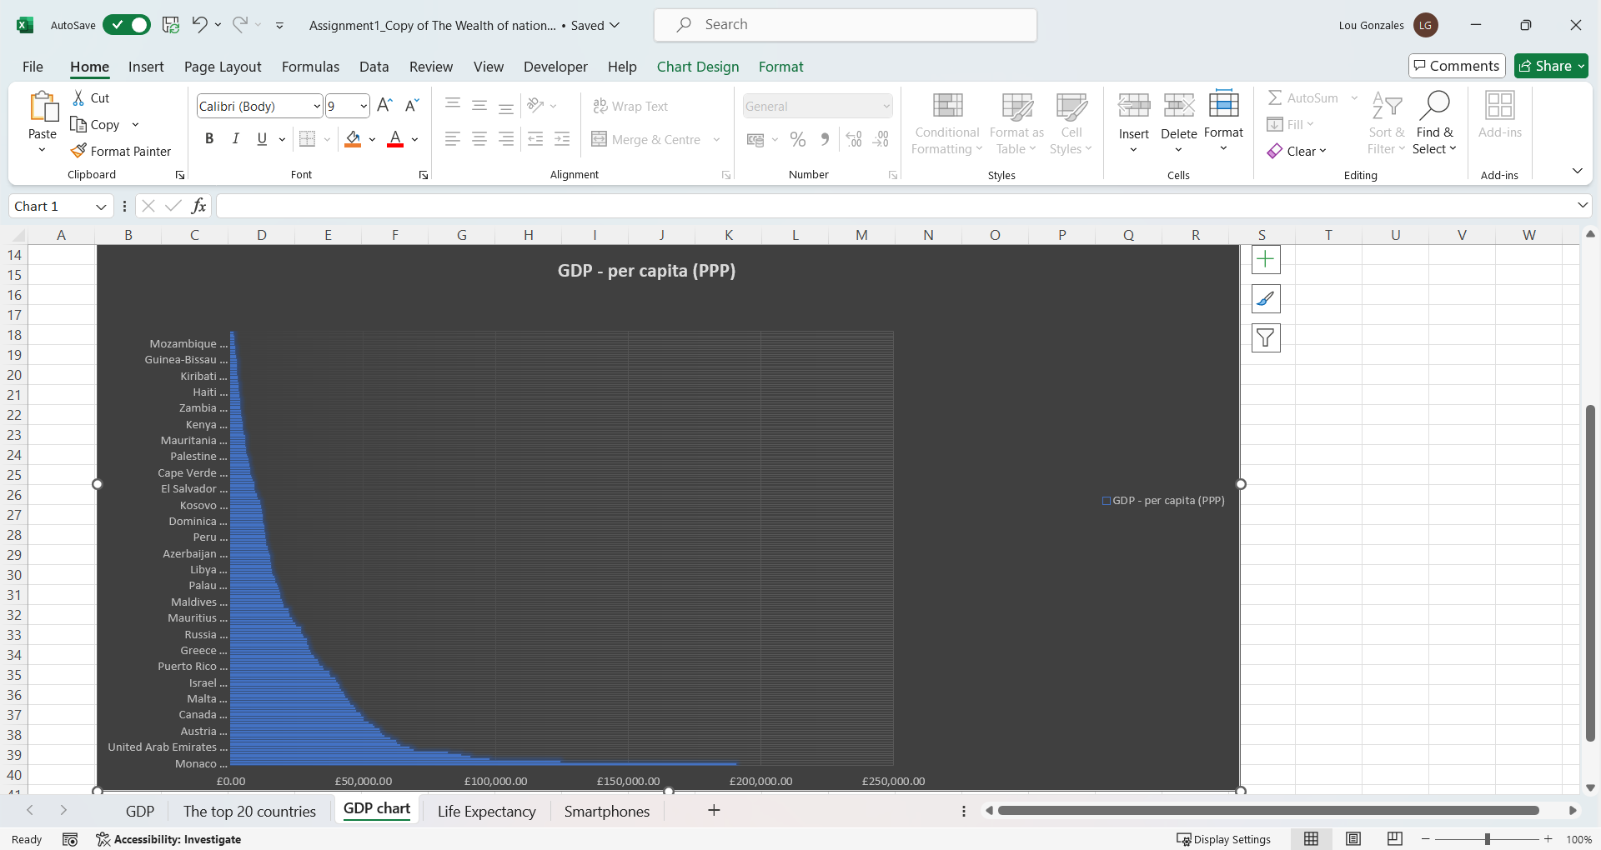

1. Creating a sort for the top 20 highest ranking countries

For sorting the top 20 highest ranking countries I applied a filter that would allow me to choose the first 20 countries only. I clicked on the arrow next to the column that we are going to filter data, in our case the arrow on column C that brought up a new window. The next, I selected Z to A from the list as we need the top 20 countries with the highest GDP, shown below.

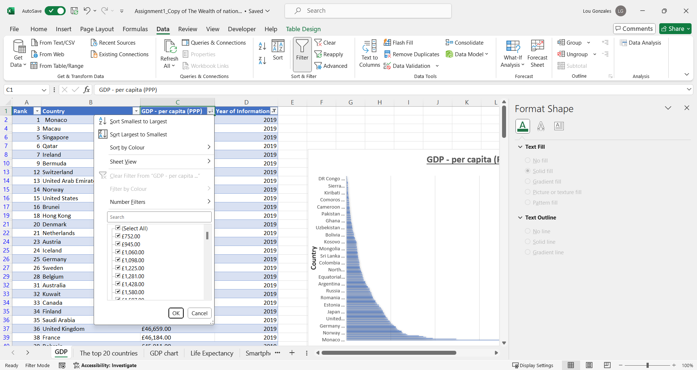

1. Creating a bar chart of the sorted data

Similarly to the previous question, a new bar chart displaying the 20 highest ranking countries was created by repeating the same steps. First, I highlighted all the rows and columns and under the Insert tab of the ribbon, I selected a suitable chart. A bar chart is required for this step and I moved it under the table as instructed.

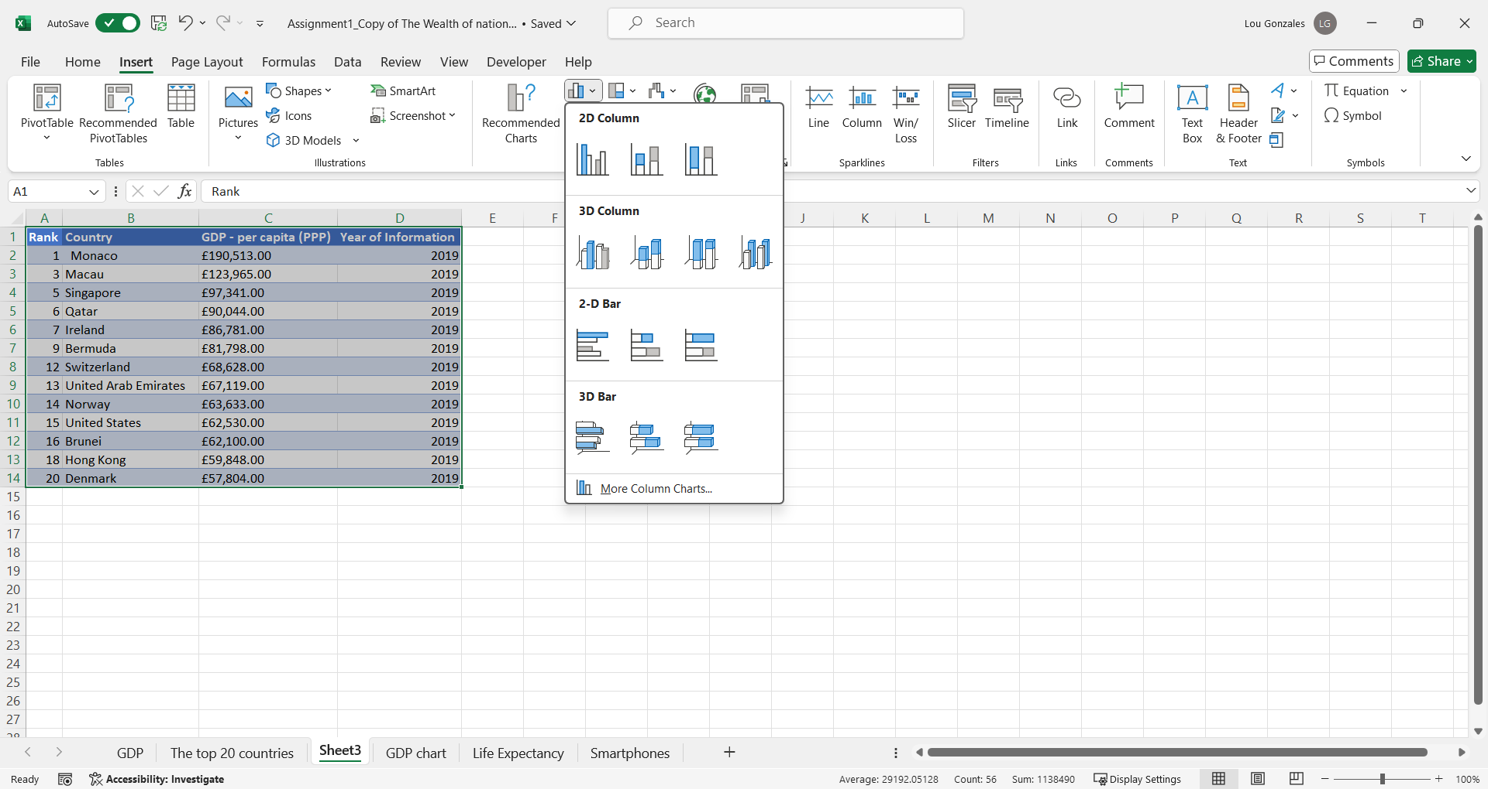

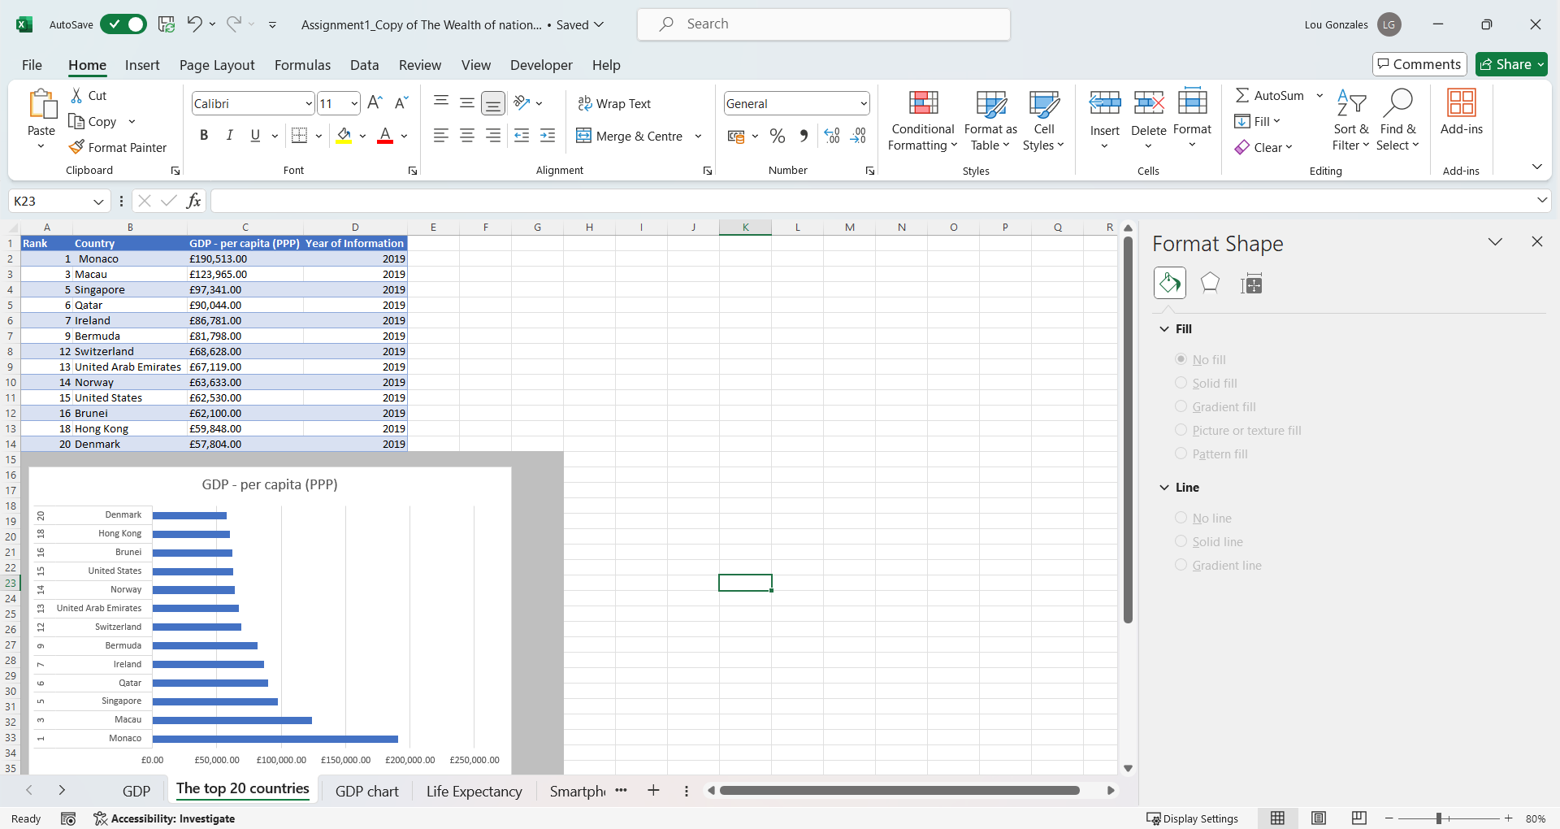

When the chart was placed under the table I added the title and axis titles to the chart.

1. Adding colour to the background

When colouring the background of the chart the area behind the chart should be highlighted first, as shown below. Then, I selected the ‘fill colour’ in the Home tab of the ribbon and selected the requested colour (grey) from the list.

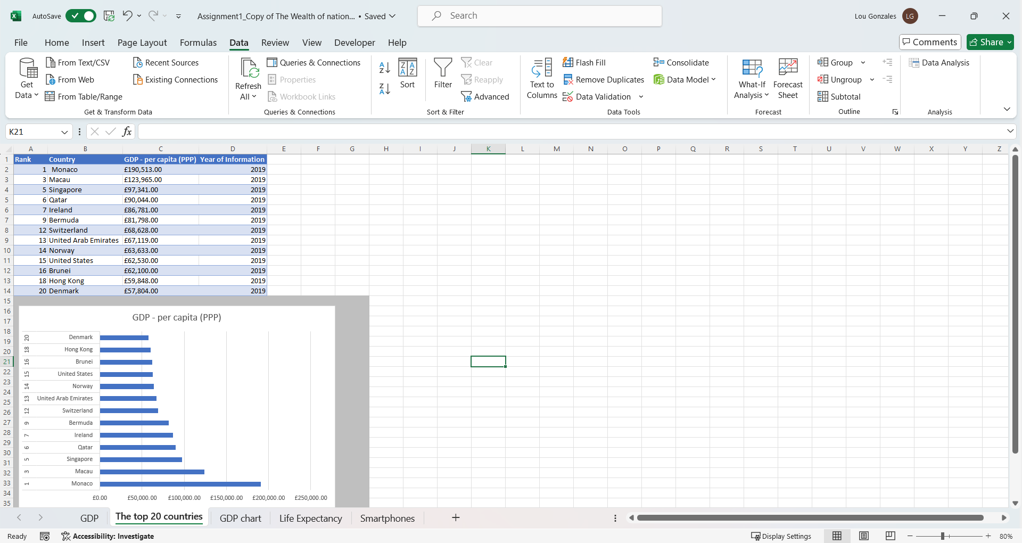

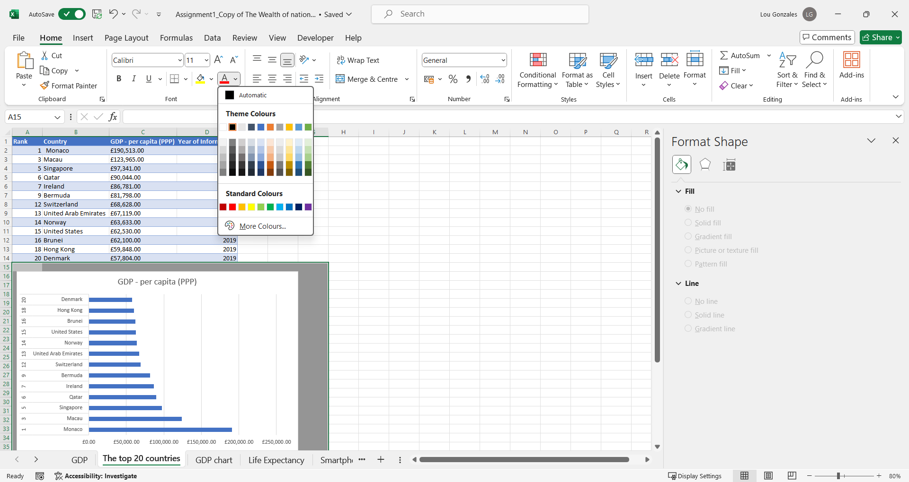

1. Macro buttons

Before recording the macro I created the buttons and chose different shapes for different function. I edited the buttons and added the names to them.

All the macro buttons were created in the same manner, with given shortcut keys: ctrl + a for printing, ctrl + b for saving the sheet and ctrl + c for copying. Macro can be found under the Developer tab as shown below. To create a macro we click on ‘Record Macro’ button. In a new window I gave it a name and a shortcut key. Once the OK button was clicked recording started and I then recorded the steps to print, save and copy. When recording was finished, I clicked on the ‘Stop recording’ button. I then assigned the relevant macro to a button.

Testing was done in an empty cell by clicking the shortcut keys to confirm that the buttons/macros work.

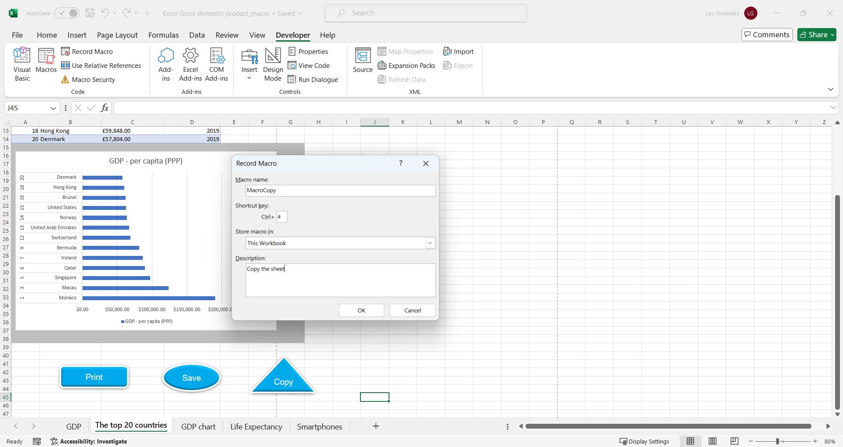

Here is the list of all three macros recorded with inserted buttons underneath.

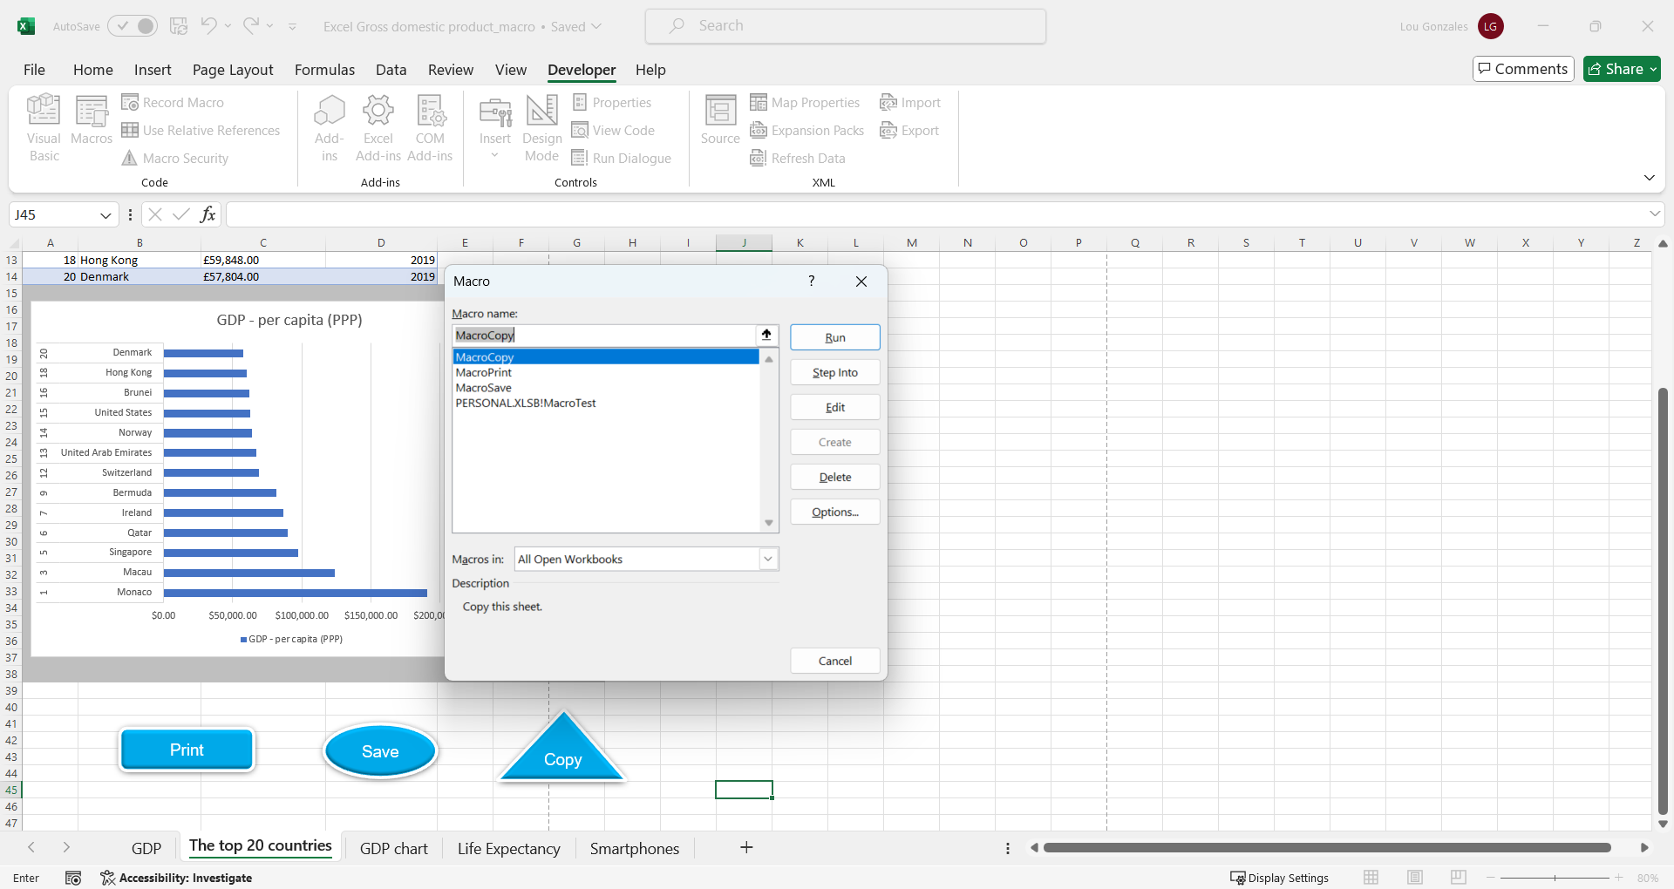

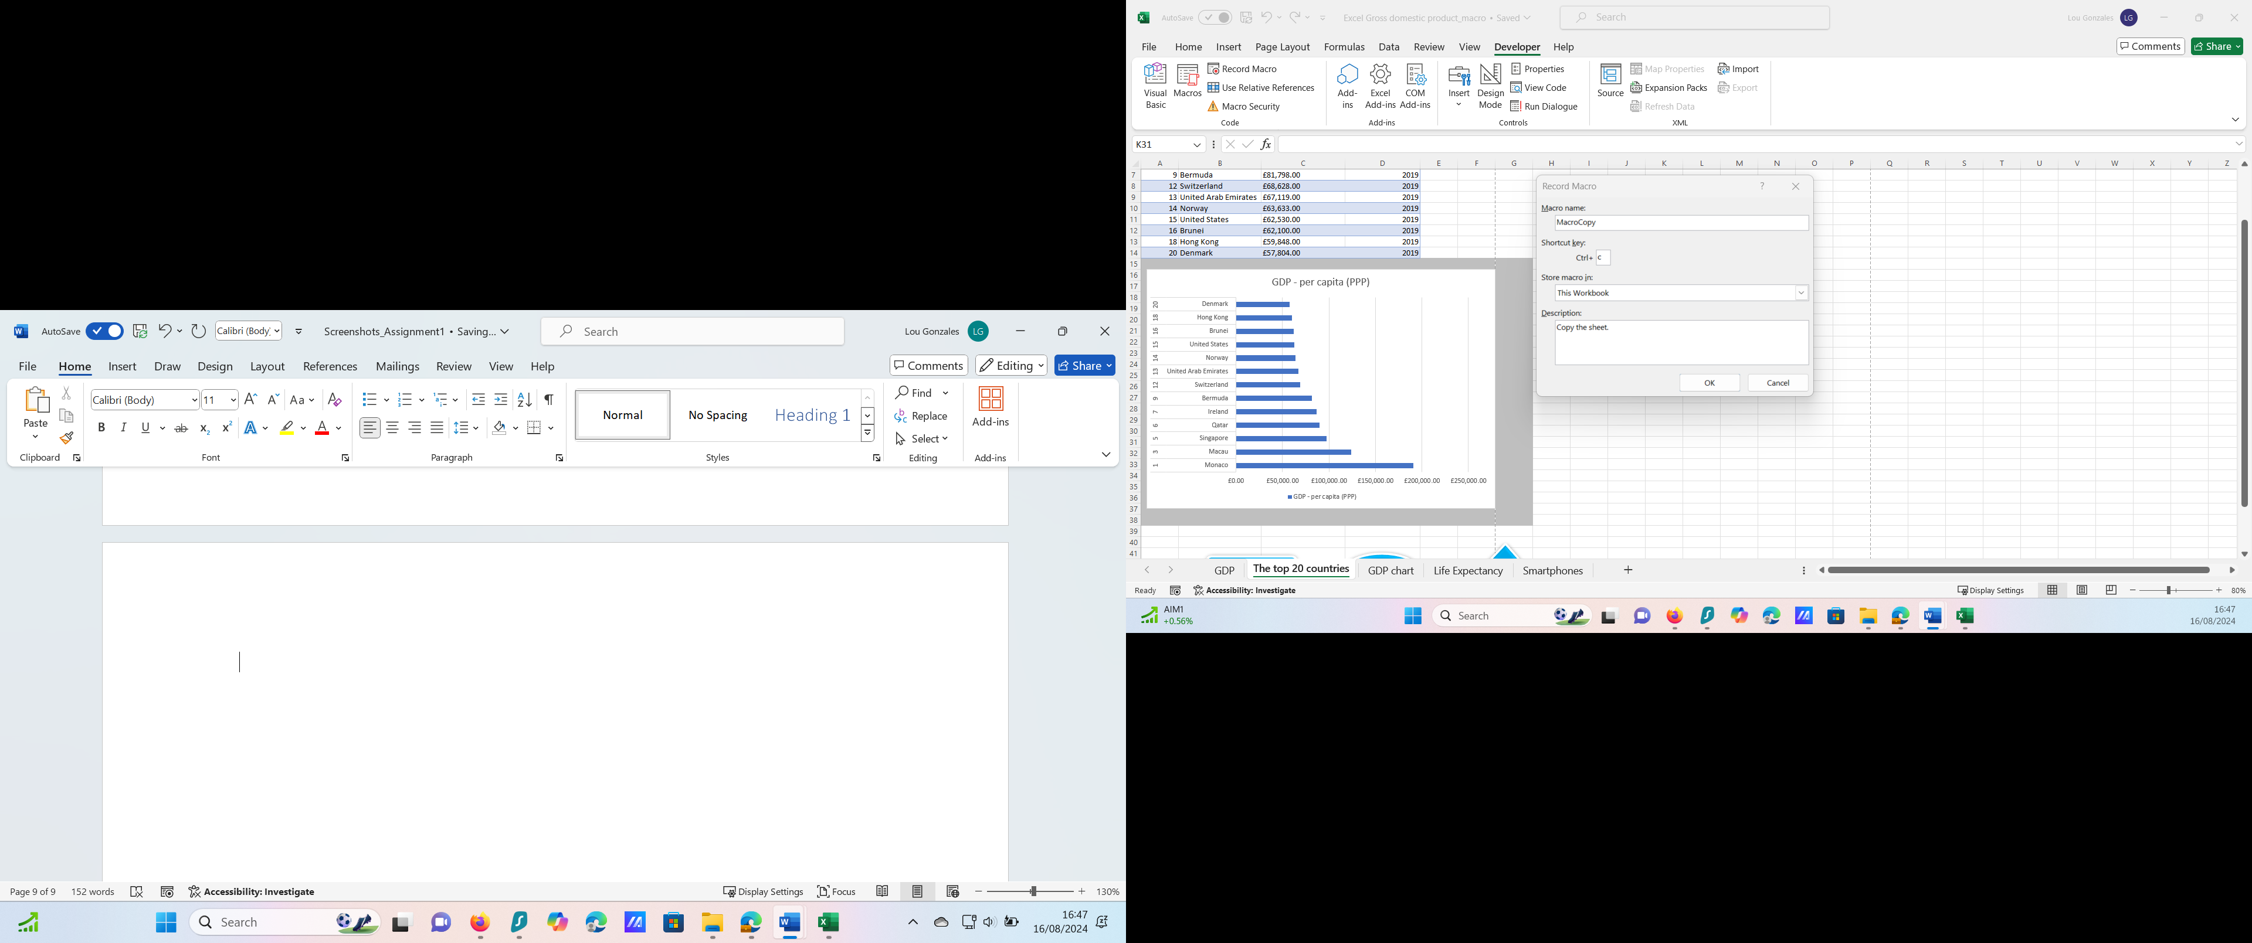

1. Copying the sheet into a Word document

(A new word document titled ‘Word Gross domestic product report 1’ has been attached under assignment in Teams – a screenshot of saving the table to a new word document, below.)

Saving the word document sheet – GDP (Gross domestic product) – First we go to the File tab and click on Save a copy which opens another window where we choose a location on our machine. The type of this document is Word.

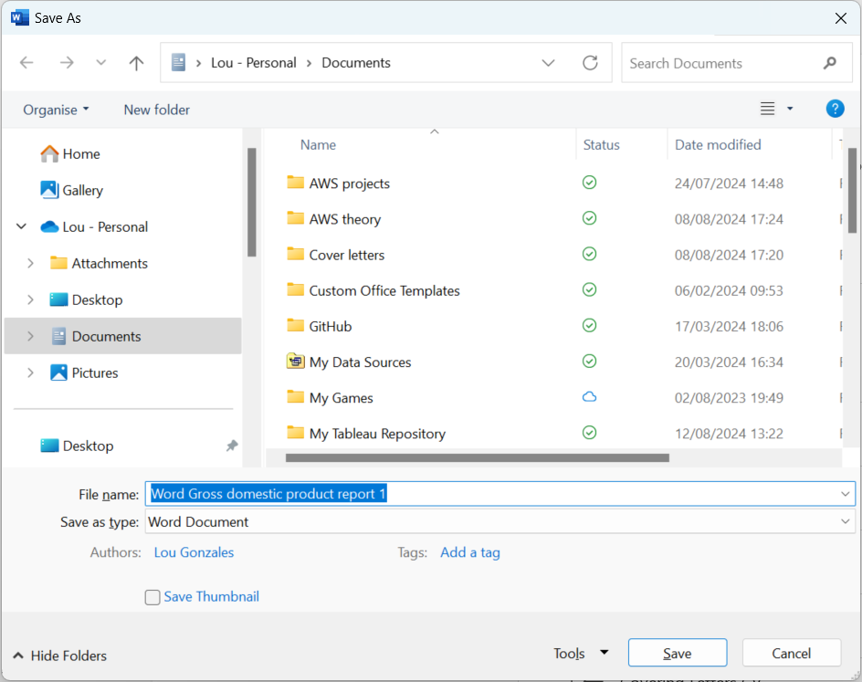

1. Adding a header and footer to the worksheet

Page layout is found in the View tab, under the ‘workbook views’ group and select ‘Page layout’ button.

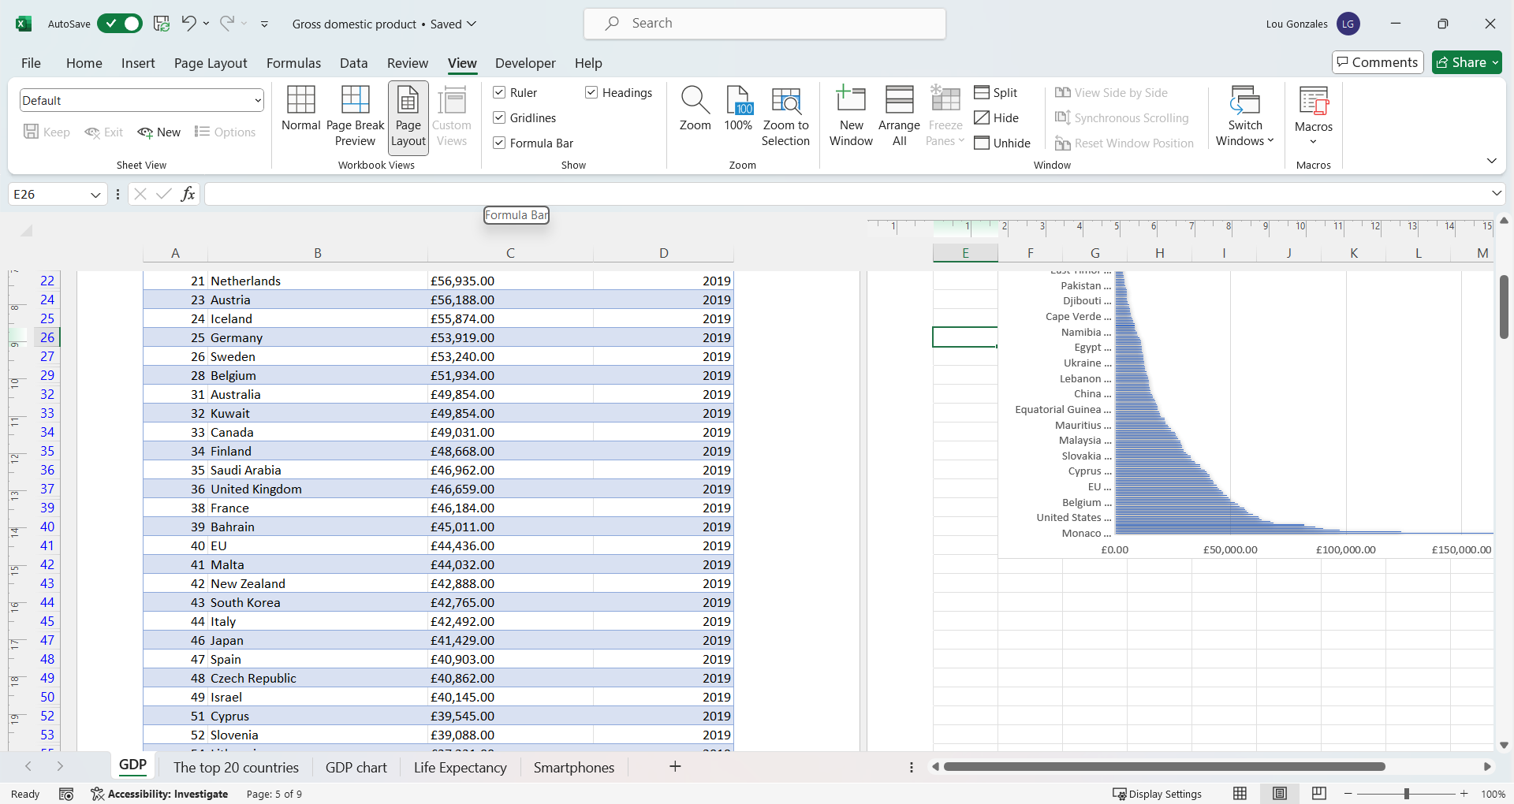

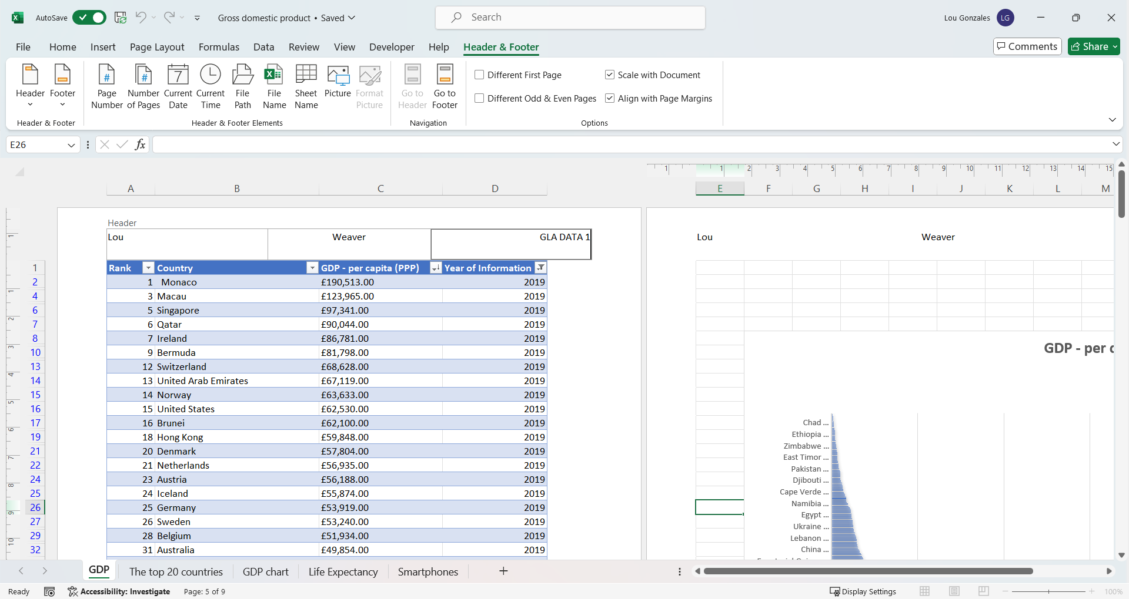

As showed above, I clicked anywhere on the worksheet to activate it and when hovering with the mouse on the top of the page, three windows next to each other appeared where I entered my name and GLA Data as requested, see below.

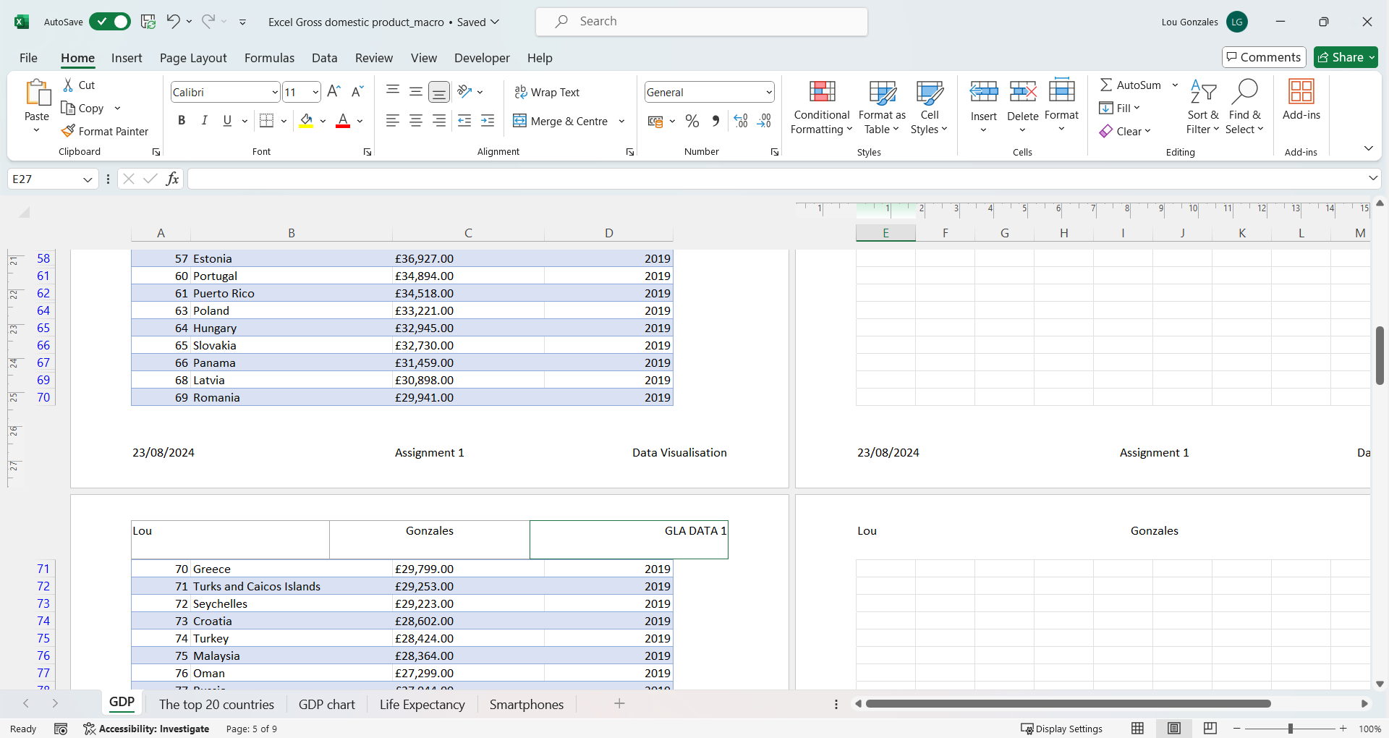

Back to normal view is found under the View tab, see below.

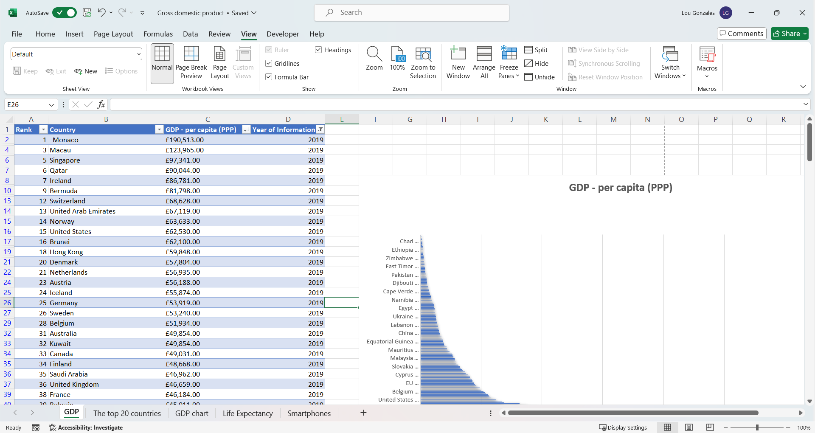

Saving the excel document is done in the same manner. I selected the File tab, clicked ‘save as’ and selected the appropriate location. Document to be saved as excel doc.

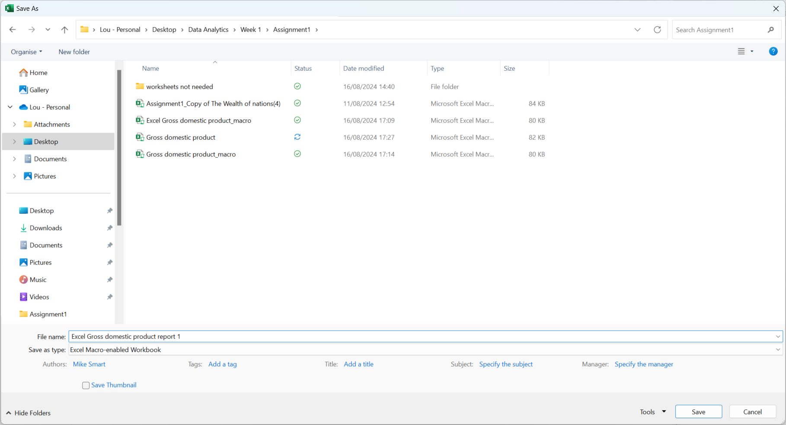

Reflection

I believe this project went well overall. As I had studied Excel at intermediate level earlier this year, I was familiar with and felt comfortable with some questions for example converting dollar sigh to pound sterling, setting a password and sorting the data for the top 20 countries.

I enjoyed creating charts; however, I found some limitations with Excel when creating the first bar chart for our extensive data. The graph didn’t display ‘Rank’ as expected and that is because of the high number of countries that was included in the dataset. This limitation is something I have to look into further with my future projects and explore more functions within Excel. The restriction with the lengthy data was overcome when applying Tableau.

Making the graph for the top 20 countries went well as data was shorter. Additionally, I liked creating data into a table and creating macros. Tableau is a powerful tool where I can use my creative side.

Overall, I enjoyed doing this project where I used the skills learnt, in the first two weeks, were consolidated and further strengthened. I look forward to exploring more functions in both Excel and Tableau.

Tableau

When we open Tableau Public, there are many data sources we can connect to. On the left pane we can see a list of different data sources like Microsoft Excel, text file and so forth.

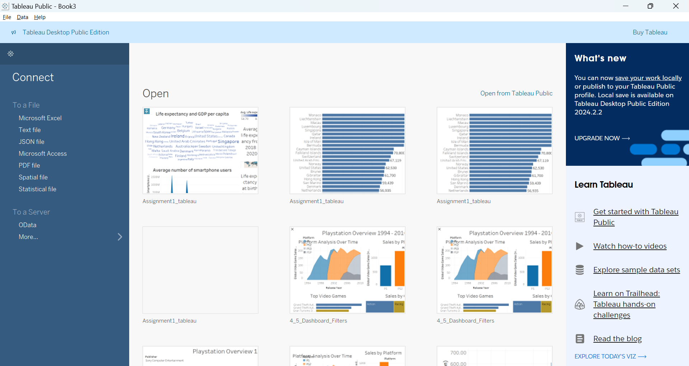

**Import data**

When clicking on Microsoft Excel it would connect us to the data source folder on the desktop. I chose ‘the wealth of nation’ file and clicked open.

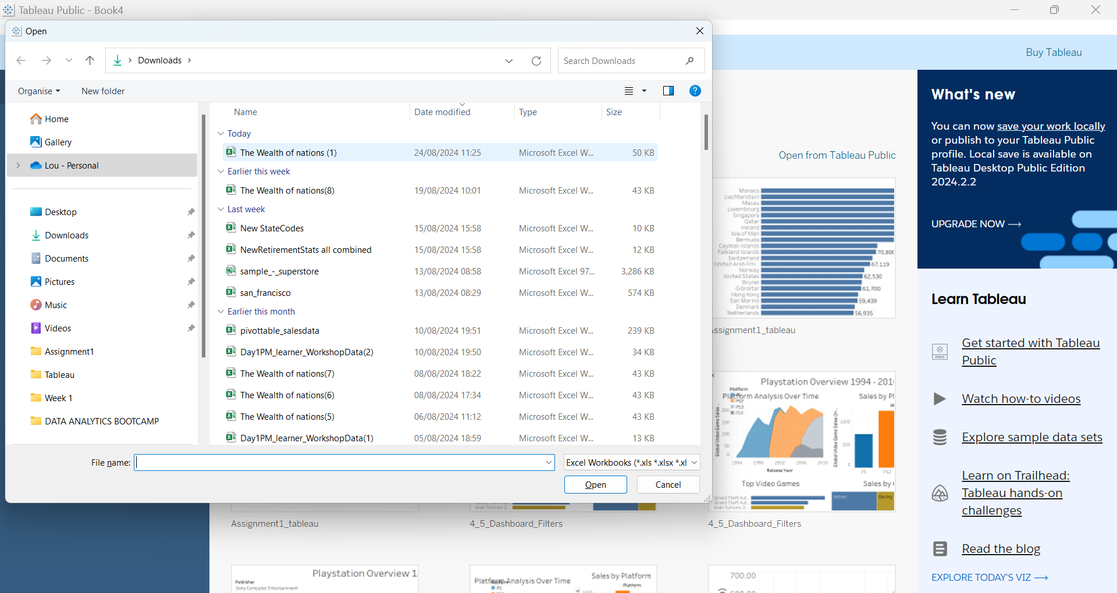

The below screenshot shows the window with the open data source. In our case we have uploaded ‘the wealth of nations’ which consist of three sheets (circled). The next step is setting relationship that can be done by dragging tables from the left pane onto the middle section. The sheets are connected by a common field, in our case ‘country’.



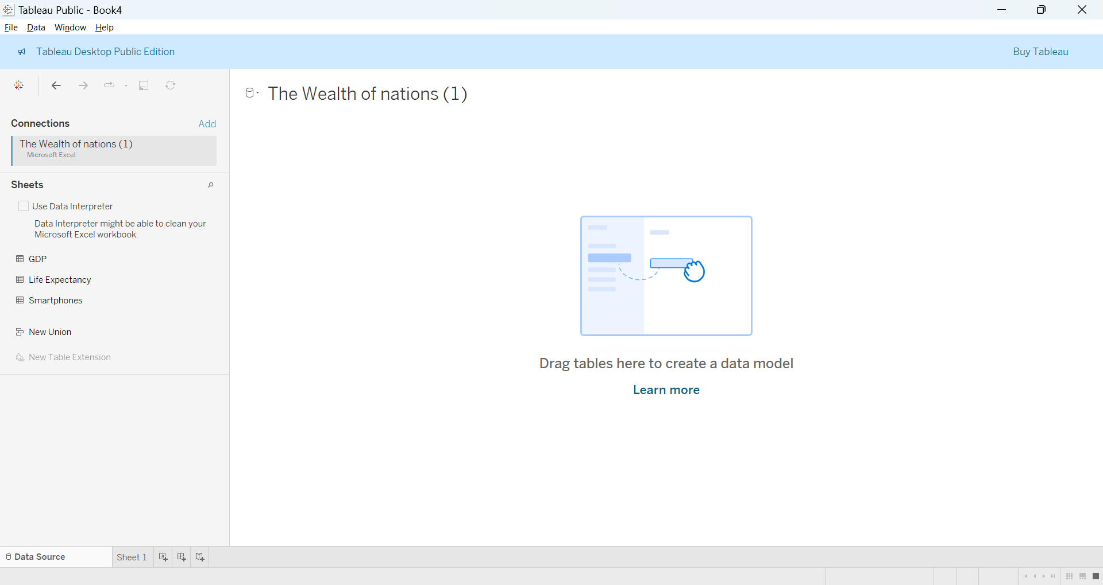

By selecting a field from a dropdown list we select ‘country’.

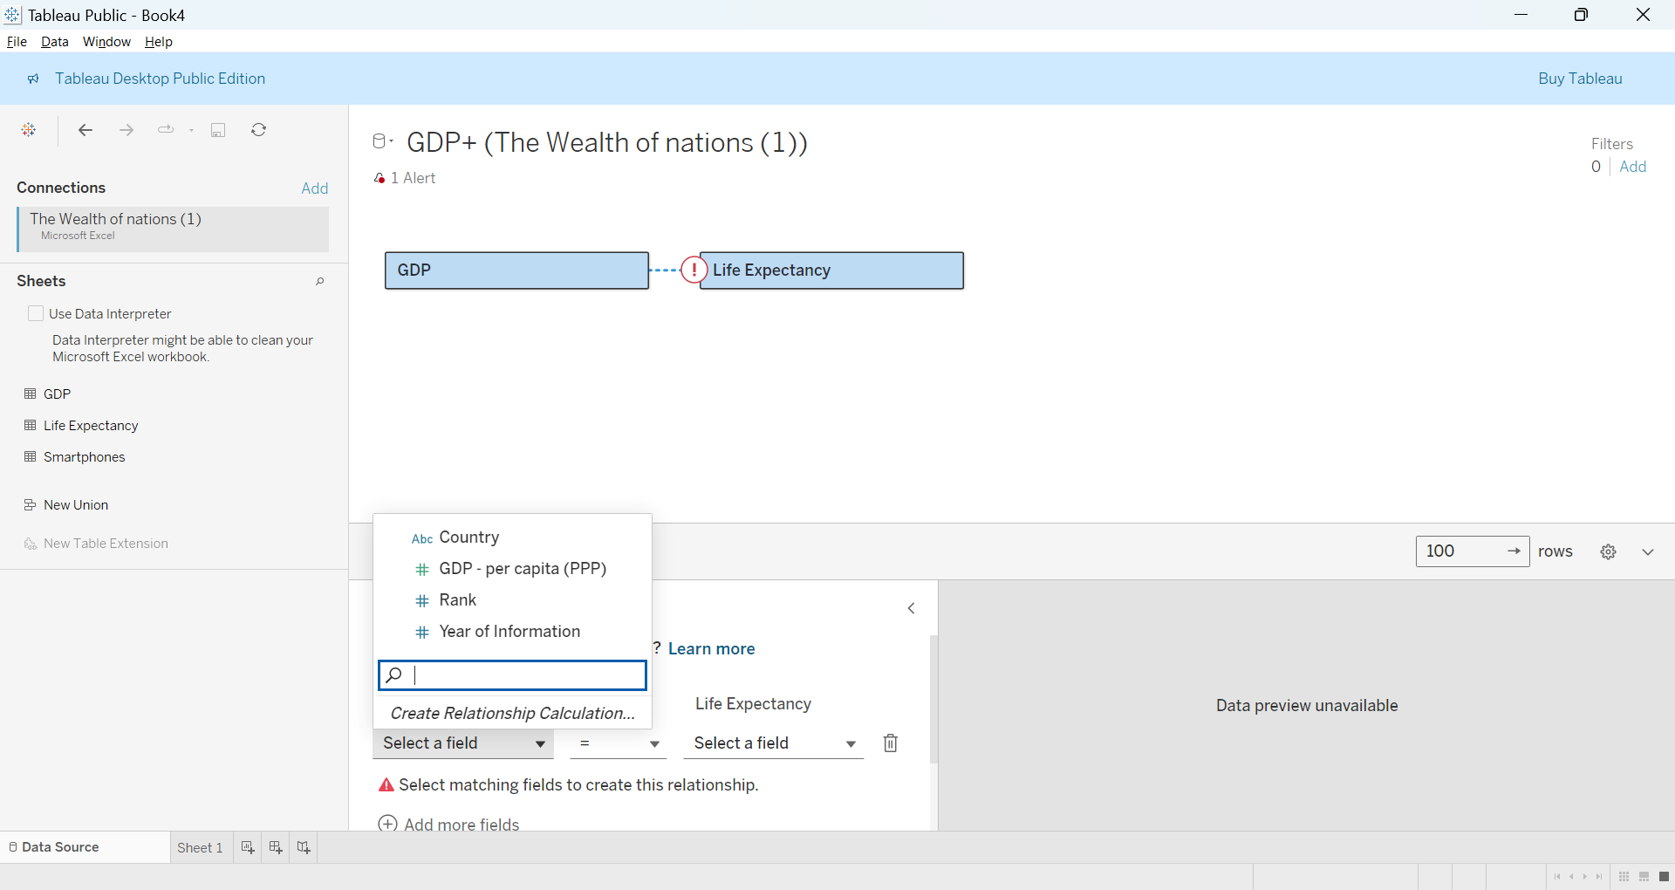

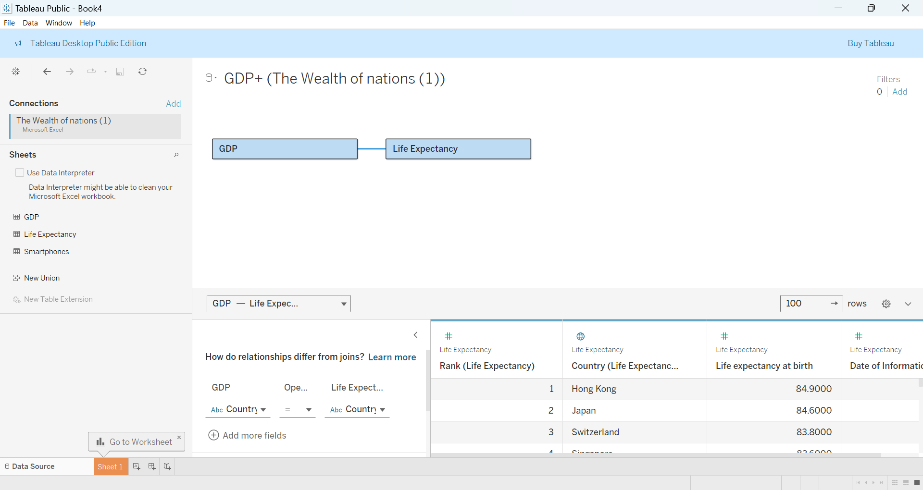

**Data types**

Once we are redirected to the data source page we can preview the data. We can check all columns and data types – number, text and locations and change if necessary. On the screenshots below it shows the correct data type.

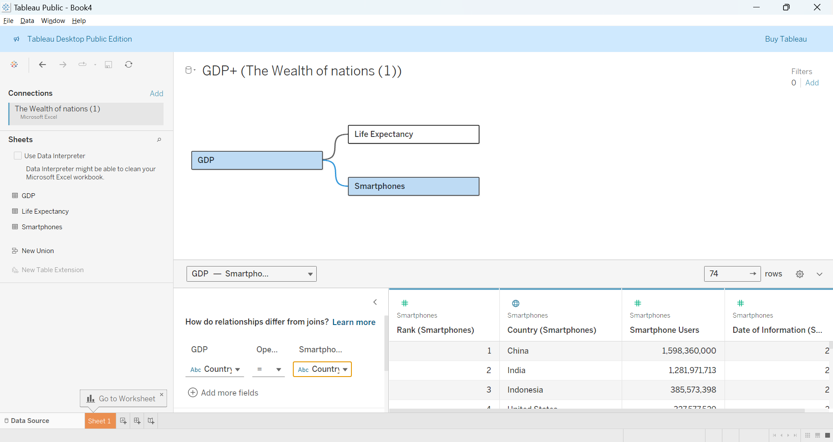



[Profile - lou.gonzales6277 | Tableau Public](https://public.tableau.com/app/profile/lou.gonzales6277/vizzes)

<https://public.tableau.com/authoring/assighment1LG_dashboard#1>

https://public.tableau.com/app/profile/lou.gonzales6277/vizzes